James Liu

CS 4495, Fall 2014

Problem Set 0

Problem Set 0, Question 1, Part A.

Image 1:

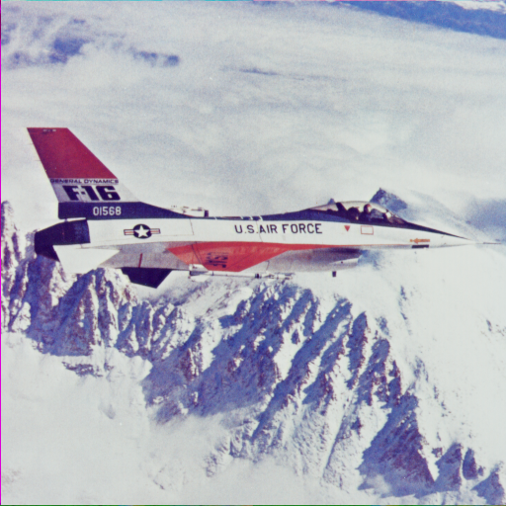

Problem Set 0, Question 1, Part A.

Image 2

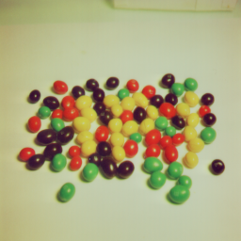

Problem Set 0, Question 2, Part A

Image 1

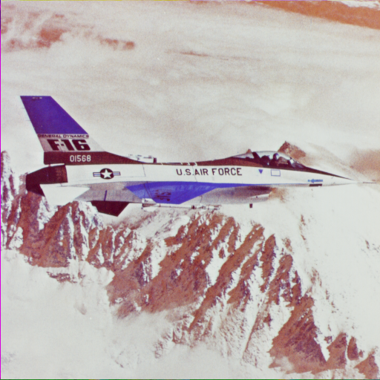

Image 1 with red and blue channels swapped.

Problem Set 0, Question 2, Part B

Image 1

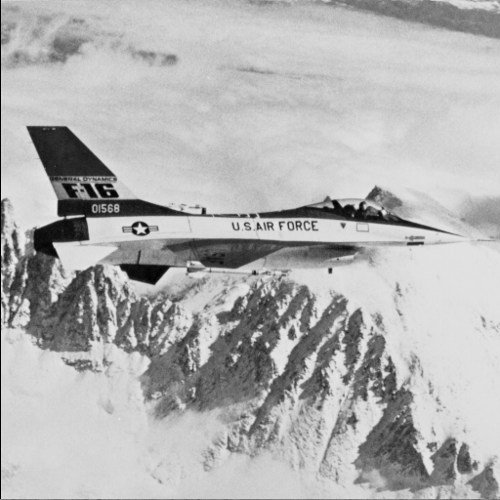

Monochrome image of the green channel on Image 1

Problem Set 0, Question 2, Part C

Image 1

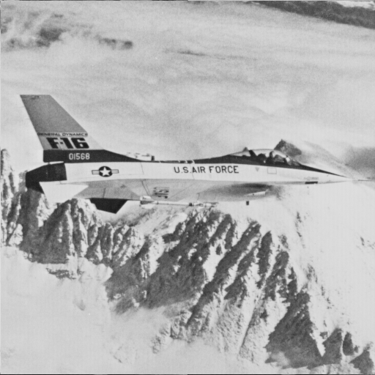

Monochrome image of the red channel of Image 1

Problem Set 0, Question 2, Part D.

I would go with the one that used the green channel. I expect a monochrome image to focus on the difference in intensity of individual parts of the image. In the image of a flying F-16, there is notably very little green in any of the major portions other than the bright white areas like the middle stripe or the clouds, whereas red can be seen in the mountain tops, the bright red stripe on the plane itself, and the aforementioned white areas. The heavy concentration of green or lack thereof in certain areas makes for a sharper image.

Problem Set 0, Question 3, Part A.

Image 1

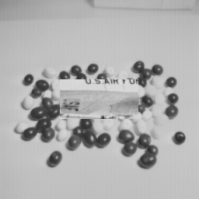

Center 50x100 pixels of Image 1 transposed onto Image 2. Used green channel to convert to monochrome.

Problem Set 0, Question 4, Part A.

Minimum: 22, Maximum: 230, Mean: 177.579.

I calculated these values by taking the individual min/max/means of each row then finding the respective min/max/mean of the set of mins/max/means. These values hold as the minimum of minimums of subsets is the absolute minimum of the entire set. The same principle holds for the maximums and means.

Problem Set 0, Question 4, Part B

Image 1



Monochrome image showing the variance from the mean on the green channel.

Problem Set 0, Question 4, Part C

Image 1

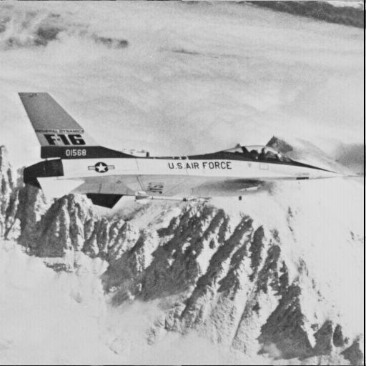

Green channel of Image 1 shifted to the left by 2 pixels.

Problem Set 0, Question 4, Part D.

Image 1

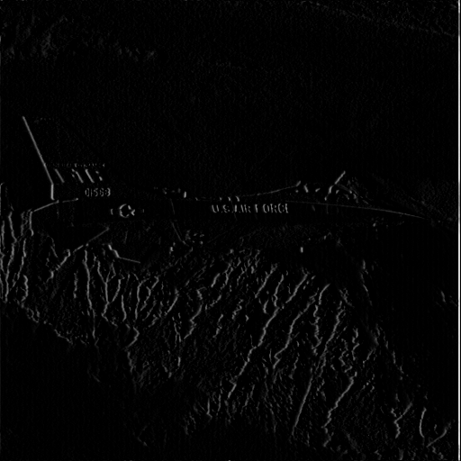

Derivative of the green channel of Image 1 with respect to X. Calculated by subtracting the shifted green channel from the original.

Problem Set 0, Question 5, Part A.

Image 1

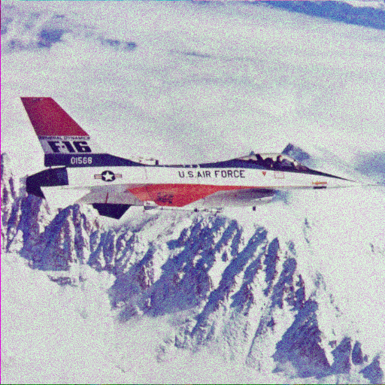

Image 1 with Gaussian noise introduced in the green channel. This is at sigma = 0.10. The noise began to be noticeable at 0.05, but barely so.

Problem Set 0, Question 5, Part B.

Image 1

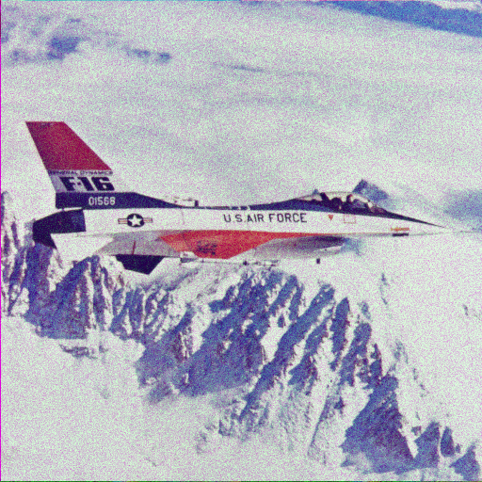

Image 1 with Gaussian noise introduced in the blue channel. This is at sigma = 0.05. The noise is as noticeable as when a Gaussian noise was introduced in the green channel with a sigma of 0.1.

Problem Set 0, Question 5, Part C.

It is much more noticeable with the noise applied to the blue channel. Since the distribution of green is highly kurtotic, a slight change to either extreme doesn’t affect the end effect on how things look to humans. With blue, the distribution of values is far more Gaussian than green’s. Even if the noise has a net zero mean, a Gaussian with a higher variance would allow sudden local extremes to appear, which is far easier to notice than then normalizing effect that the Gaussian noise would have when used on the green channel.